Start

Prompt itemBarcode

Get itemBarcode

Prompt amountOf_stock

Get amountOf_stock

Compare rate of sale to stock on hand

If (rateOf­_sale> stockOn_hand) Then

Display “re-oder_stock”

Else

Display “don’t re-order_stock”

Display RunStock_checkAfter_7_Days

ENDIF

END

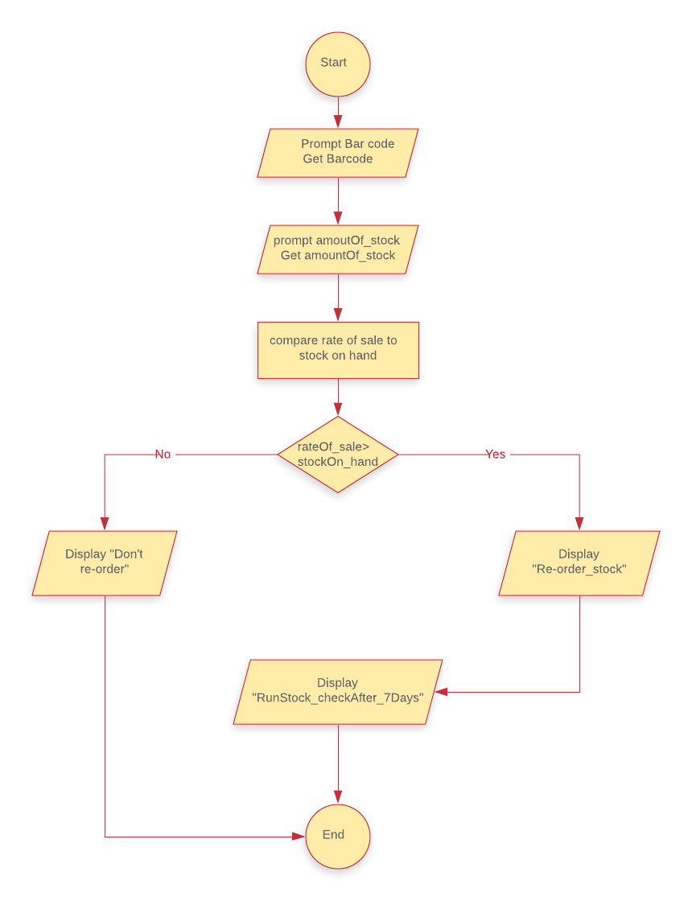

STUDENT NAME: ABILIO JOAO PAULO

STUDENT NUMBER:220031193